# ONLINE EVENT MANAGEMENT SYSTEM

A Project Report Submitted in the partial fulfillment of the requirements for the award of the degree of

##### **BACHELOR OF TECHNOLOGY**

**In**

##### **DEPARTMENT OF COMPUTER SCIENCE ENGINNERING**

**&**

##### **DEPARTMENT OF COMPUTER SCIENCE AND INFORMATION TECHNOLOGY**

**By**

|  |  |
| --- | --- |
| **Akshitha Kiran** | **:2320030374** |
| **M.Rishika** | **:2320030471** |
| **Trivikram** | **:2320030042** |

Under the Esteemed Guidance of

**Yerragudipadu Subbarayudu**

**Assistant Professor**

**Department of Computer Science and Engineering**

**K L (Deemed to be) University DEPARTMENT OF COMPUTER SCIENCE ENGINEERING**

**&**

**DEPARTMENT OF COMPUTER SCIENCE AND INFORMATION TECHNOL**

**Declaration**

The Project Report entitled **“Building Stronger Customer Relationships through Innovative CRM Technology**” is a record of Bonafide work of **Akshitha Kiran -2320030374, M.Rishika – 2320030471, Trivikram – 2320030042** submitted in partial fulfillment for the award of B. Tech in Computer Science and Engineering (or) Computer Science and Information Technology to the K L University. The results embodied in this report have not been copied from any other departments/University/Institute.

**Akshitha Kiran – 2320030374**

**M.Rishika – 2320030471**

**Trivikram– 2320030042**

**K L (Deemed to be) University DEPARTMENT OF COMPUTER SCIENCE ENGINEERING**

**&**

**DEPARTMENT OF COMPUTER SCIENCE AND INFORMATION TECHNOLOGY**

##### **CERTIFICATE**

This is certify that the mini project based report entitled “**Building Stronger Customer Relationships through Innovative CRM Technology**”is a bonafide work done and submitted by **AkshithaKiran-2320030374,M.Rishika 2320030471,Trivikram– 2320030042** in partial fulfillment of the requirements for the award of the degree of **BACHELOR OF TECHNOLOGY** in Department of Computer Science Engineering, K L (Deemed to be University), during the academic year **2024-2025.**

**Signature of the Guide**

**Signature of the Course Coordinator Signature of the HOD**

##### **ACKNOWLEDGEMENT**

The success in this project would not have been possible but for the timely help and guidance rendered by many people. Our wish to express my sincere thanks to all those who has assisted us in one way or the other for the completion of my project.

Our greatest appreciation to my Course Coordinator **Yerragudipadu Subbarayudu**, and my guide **Yerragudipadu Subbarayudu,** Department of Computer Science which cannot be expressed in words for his/her tremendous support, encouragement and guidance for this project.

We express our gratitude to **Dr. Ramesh Babu (CSE)/Dr. Kaja Shareef (CSIT)**, Head of the ***Department for Computer Science Engineering/ Department for Computer Science and Information Technology***for providing us with adequate facilities, ways and means by which we are able to complete this project-based Lab.

We thank all the members of teaching and non-teaching staff members, and also who have assisted me directly or indirectly for successful completion of this project. Finally, I sincerely thank my parents, friends and classmates for their kind help and cooperation during my work.

**Akshitha Kiran – 2320030374**

**M.Rishika – 2320030471**

**Trivikram– 2320030042**

**Abstract**

In today's customer-centric business environment, companies often struggle to address and resolve customer issues efficiently. Traditional methods of handling customer problems, such as manual tracking, fragmented communication channels, and inconsistent follow-up, lead to delays, frustration, and customer dissatisfaction. These challenges hinder businesses from providing seamless and timely support, ultimately impacting customer loyalty and retention. To solve these customer problems effectively, businesses need a comprehensive system that integrates customer support functions, streamlines communication, and ensures consistent follow-up. The proposed solution aims to enhance the customer support experience by leveraging technology to provide a centralized platform for managing customer inquiries, automating responses, tracking issue resolution, and generating insights for continuous improvement.

**Index**

|  |  |  |  |
| --- | --- | --- | --- |
| **S. No.** | **Chapters** | **Topics** | **Page.no** |
|  |  | Acknowledgement |  |
|  |  | Abstract |  |
| 1 | Introduction | 1.1 Background of the project  1.2 Problem statement  1.3 Scope of the project  1.4 Objective(s)  1.5 Importance of the application  1.6 Target users/audience | 1-10 |
| 2 | System Requirements | 2.1 Hardware requirements  2.2 Software requirements  2.3 Development tools and frameworks | 11-20 |
| 3 | Technology Stack | 3.1 Front-end (e.g., React.js, Angular, HTML/CSS)  3.2 Back-end (e.g., Node.js, Django, Spring Boot)  3.3 Database (e.g., MongoDB, MySQL, PostgreSQL)  3.4 Version Control (e.g., Git, GitHub)  3.5 APIs or External services (e.g., Firebase, Stripe) | 21-30 |
| 4 | System Architecture | 4.1 High-level architecture diagram  4.2 Description of each layer (frontend, backend, database)  4.3 Deployment architecture (e.g., cloud, local, CI/CD pipelines) | 31-35 |
| 5 | Design | 5.1 Wireframes or mockups  5.2 ER Diagram / Database schema | 36-42 |
| 6 | Implementation | 6.1 Module-wise implementation  6.2 Front-end logic (UI rendering, state management)  6.3 Backend logic (routes, controllers, business logic)  6.4 Database connectivity  6.5 API integration  6.6 Authentication & Authorization | 43-55 |
| 7 | Features | 7.1 List of main features  7.2 How each feature works (user perspective + technical description) | 56-60 |
| 8 | Testing | 8.1 Postman testing (frontend/backend)  8.2 Integration testing  8.3 Tools used for testing  8.4 Test cases and results | 61-67 |
| 9 | Deployment | 9.1 Steps to deploy  9.2 Environment configuration  9.3 Hosting of frontend and backend | 68-73 |
| 10 | Challenges & Limitations | 10.1 Issues faced during development  10.2 Solutions applied  10.3 Current limitations or known bugs | 74-80 |
| 11 | Future Enhancements | 11.1 Planned features  11.2 Possible integrations or optimizations | 81-88 |
| 12 | Conclusion | 12.1 Summary of the project  12.2 What was achieved  12.3 Skills learned during development | 89-100 |
| 13 | References | - Books, tutorials, APIs, documentation sites used |  |
| 14 | Appendices | - Screenshots of the app  - Sample code snippets  - Installation/setup instructions  - User manual or guide  -certifications |  |

**CHAPTER 1**

**Introduction**

**1.1 Motivation**

In today’s competitive market, building and maintaining strong relationships with customers is more important than ever. However, many businesses struggle to manage customer information, communication, and follow-ups effectively. Using scattered tools like spreadsheets, emails, or manual records often leads to missed opportunities, poor customer service, and lack of coordination between teams. To overcome these problems, businesses need a centralized system that helps them manage customer interactions in an organized and efficient way. A **CRM system** makes it easier to store customer data, track communication history, schedule follow-ups, and analyze customer behavior .The main motivation for this project is to help businesses improve customer relationships, increase sales, and provide better service by using a smart and easy-to-use CRM solution.

**1.2 Objective**

The main objective of this CRM (Customer Relationship Management) system is to help businesses manage customer relationships more effectively and improve overall customer experience. This system aims to Store and organize customer information in one central place.Track and manage all customer interactions and communications.Help teams follow up with customers on time and avoid missed opportunities.Improve coordination between sales, support, and marketing teams.

**1.3 What is Web Development?**

Web development in CRM refers to creating or customizing web-based tools, pages, and integrations that enhance how a CRM system operates. It can range from building simple customer input forms to complex web applications that interact with CRM data.

Tasks include:

Web engineering and design tailored to CRM

Developing web portals for customers, partners, or staff

Client-side/server-side scripting for CRM features

CRM server setup and network configuration

Using CMS tools for easier content updates

In a CRM context, web development focuses on coding and integration rather than visual design. It enables CRM users to manage customer data, automateworkflows, and provide better online services.

**1.4 What is Website?**

In CRM, a **website** is often used as a customer-facing platform that connects to the CRM system. It may collect leads, support tickets, feedback, or customer activity data.

Example: A company's website with a contact form that sends leads directly to Salesforce or HubSpot.

Websites can be:

**Public** (accessible by customers, like product pages or support portals)

**Private** (used internally, like employee dashboards)

Each website is accessed via a URL and serves a specific CRM-related purpose—sales, support, marketing, etc.

**1.5 What is Webpage?**

A **web page** in CRM is a single document or screen used to display or collect information related to customer interactions.

Examples:

A **lead capture page** that pushes data into the CRM

A **customer profile page** pulling info from the CRM

A **ticket submission page** for customer support

Web pages are usually built with HTML/CSS and enhanced by scripts (JavaScript) to interact with CRM APIs or forms. They act as the bridge between the user and the CRM backend.

**CHAPTER 2**

**Software Requirement**

* 1. **Problem Statement**

The current customer relationship management process is disjointed, with customer data scattered across multiple platforms. This leads to data inconsistencies, poor visibility into customer interactions, and weak collaboration between sales, marketing, and support teams. As a result, customer satisfaction is declining, communication is inefficient, and the company is losing valuable sales opportunities. A centralized, integrated, and user-friendly CRM system is essential to streamline operations, enhance customer experiences, and drive business growth.

* 1. **Technologies used**

In the development of a CRM web application, various front-end and back-end technologies, libraries, frameworks, and tools are utilized to ensure a responsive, scalable, and user-friendly solution.

**Front-End Development**

**Tools:**

Visual Studio Code (VS Code)

**Languages & Frameworks:**

**HTML**: Standard markup language for structuring web content.

html

CopyEdit

<!DOCTYPE html>

<html>

<head><title>CRM Page</title></head>

<body>

<h1>CRM Dashboard</h1>

<p>Welcome, user!</p>

</body>

</html>

**CSS**: Styles HTML elements across screens and devices.  
 **Types of CSS:**

*Inline CSS*: Affects individual elements directly (not recommended for CRM).

*Internal CSS*: Defined in <head>, used for page-specific styling.

*External CSS*: Stored in .css files; promotes reusability and cleaner code.

**Frameworks:**

**React.js, Angular, Vue.js**: Used to build dynamic and interactive CRM interfaces.

**Libraries:**

**Bootstrap**: Mobile-first CSS framework for responsive design and UI components.

**Axios**: For making HTTP requests to backend APIs.

**ESLint**: Code quality and error checking.

**Webpack**: Module bundler to optimize and compile resources.

**Back-End Development**

**Framework:**

**Spring Boot** (Java): Used to create RESTful services and manage CRM logic.

**Languages:**

**Java**: Main programming language for backend services.

**Libraries & Tools:**

**Spring Data JPA**: Database interaction.

**Spring Security**: Authentication and authorization.

**Spring Mail**: Email handling.

**Lombok**: Reduces boilerplate Java code.

**Hibernate**: ORM tool for database operations.

**Database Management**

**DBMS:**

**MySQL**, **PostgreSQL**, or **MongoDB** (depending on use case)

**Tools:**

**Flyway**, **Liquibase**: For versioning and managing database migrations.

**DBeaver**: GUI tool for managing databases.

**API & Integrations**

**RESTful APIs**: Facilitate communication between front-end and back-end systems.

**Third-Party Services**:

**SendGrid / Mailgun**: For transactional email delivery.

**Hosting & Infrastructure**

**Cloud Platforms:**

**AWS**, **Azure**, **Google Cloud**

**Tools & Services:**

**Docker**, **Kubernetes**: Containerization and orchestration.

**Load Balancing**, **CDN**: Enhance performance and availability.

* 1. **Software Used**

**2.3 Software Used**

**2.3.1 Brackets (Text Editor)**

Brackets is a free, open-source text editor developed by Adobe, ideal for web development. It supports live HTML, CSS, and JavaScript editing, making it useful for designing responsive CRM user interfaces. With inline editing, live preview, and extension support, Brackets helps streamline front-end development. It is cross-platform and widely used in the web dev community.

**Software Requirements**

**Functional Requirements**

**User Management** – Login, roles, and profile control.

**Customer Data Management** – Centralized customer records and segmentation.

**Interaction Tracking** – Logs all customer communications.

**Sales Pipeline** – Tracks leads, deals, and conversions.

**Analytics & Reporting** – Dashboards and insights into user behavior.

**Automation** – Email campaigns, tasks, and workflows.

**Customer Support** – Ticket system and support integration.

**Mobile Access** – CRM available on mobile devices.

**Non-Functional Requirements**

**Scalability** – Handles growth in users and data.

**Performance** – Fast response and data processing.

**Security** – Encryption, access control, and compliance.

**Reliability** – High uptime and backup support.

**Usability** – Intuitive UI and user documentation.

**Compatibility** – Works across devices and integrates with other tools.

**CHAPTER 3**

**Software Design**

**3.1 DFD**

**A Data Flow Diagram (DFD) visually represents how data moves through a Customer Relationship Management (CRM) system. It shows the flow of information between external entities (like customers or sales reps), processes (like login, data entry, or lead tracking), and data stores (like customer databases).**

**Unlike flowcharts, DFDs do not include control logic, loops, or decisions—they focus purely on how data enters, flows, is stored, and exits the system.**

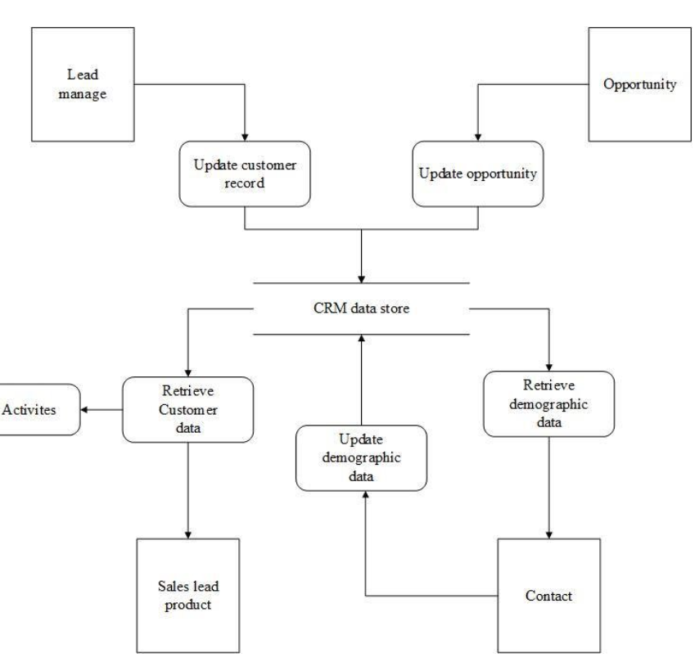

Fig No. 3.1 DFD LEVEL-0

**CHAPTER 4**

**Implementation and User Interface**

**4.1 Web Page Details**

1. Home Page
2. About Us
3. Top 6 Restaurant present in Mathura
4. Write a Review
5. People Reviewed

**4.2 Detailed Description of Pages**

**1. Home Page** The home screen consists of screen where one can browse through the page for getting information about the usefulness of the web page

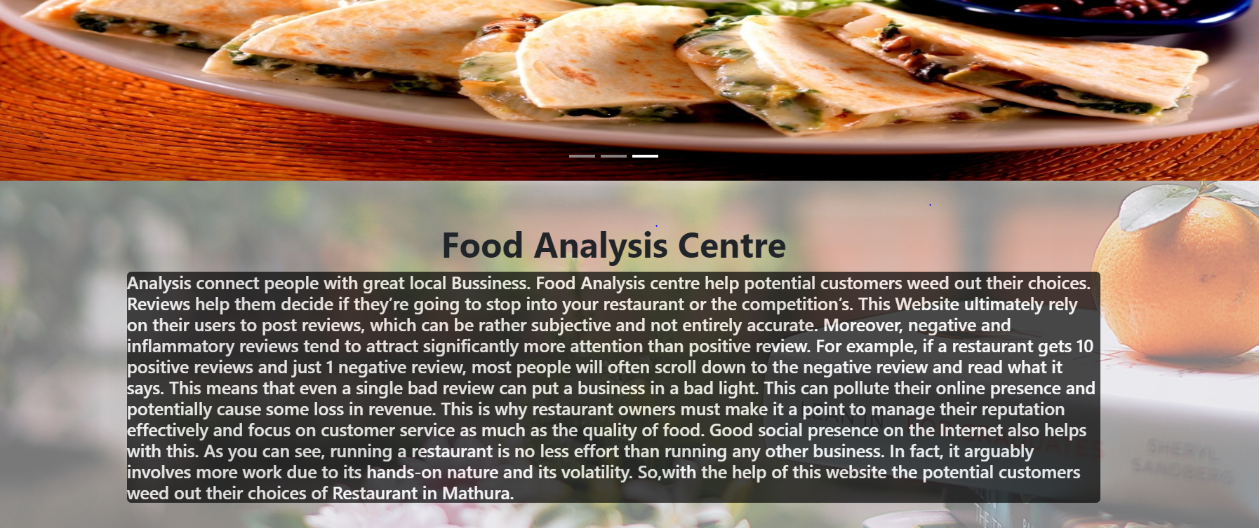

Fig No. 4.1 Home Page

1. **Top 6 Restaurant Page:** The screen consists of screen where one can browse through the top 6 best Rated Restaurant present in Mathura.

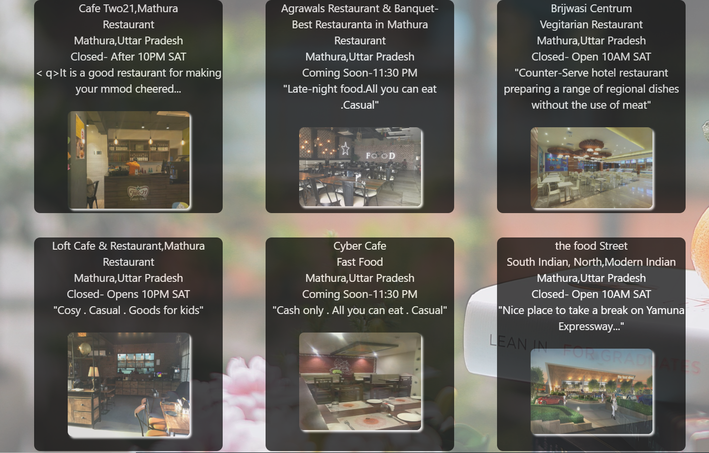

Fig No. 4.3 2. Top 6 Restaurant Page

1. **Write Your Review:** User can also Write a Review of any stuff for any Restaurant Present in Mathura, Because public opinion matters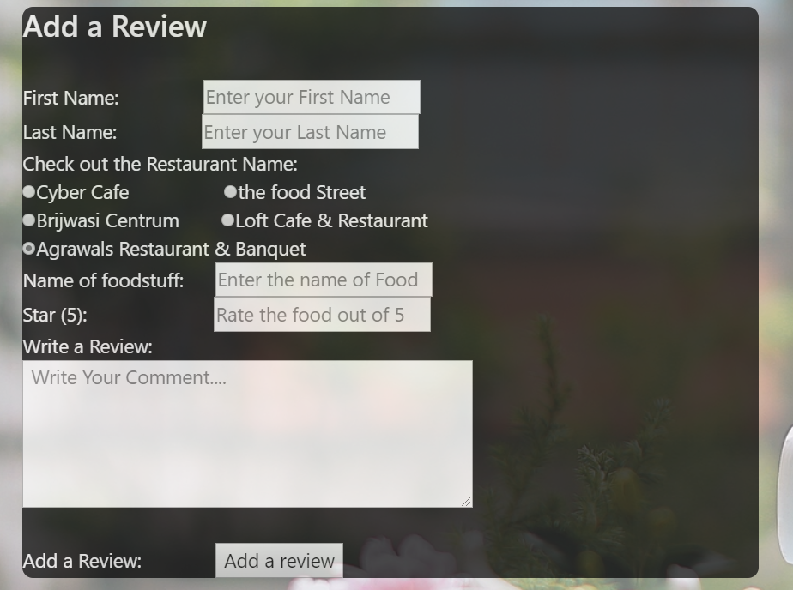

Fig 4.3 Products Page

1. **Review of the Day: –** Here on the Screen some Review Added by the user will be shown.

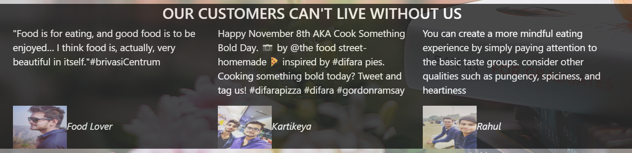

Fig 4.5 Review of the Day Page

CHAPTER 5

# Conclusion and Future Aspects

**5.1 Conclusion**

**In conclusion, the proposed CRM system effectively addresses the challenges of customer management by centralizing data, streamlining communication, and automating support functions. It enhances customer satisfaction, improves operational efficiency, and supports data-driven decision-making, providing businesses with a reliable and scalable platform to build stronger customer relationships and drive growth.**

**5.2 Future Aspects**

**AI Query Assistant for instant customer support.**

**New Restaurant Listings & Reviews to engage users.**

**SMS Notifications for timely updates and offers.**

**Social Media Integration for better interaction tracking.**

**Predictive Analytics to forecast customer needs.**

**Enhanced Mobile App with offline and push notification features.**

**IoT Integration for smarter, personalized services.**

**CHAPTER 6**

**Bibliography**

* <https://www.salesforce.com/what-is-crm/>
* <https://blog.hubspot.com/customers/what-is-crm>
* <https://www.zoho.com/crm/what-is-crm.html>
* <https://www.freshworks.com/crm/what-is-crm/>
* <https://dynamics.microsoft.com/en-us/crm/overview/>
* <https://www.superoffice.com/crm/what-is-crm/>
* <https://www.investopedia.com/terms/c/customer_relationship_management.asp>

# CHAPTER 7

# Appendices

**7.1 CSS**

1. /*      CSS for the BackGround Image*/
2. .back{
3. **background-image**: url(../Image/bg_hd%20wallpaper.jpg);
4. **width**: 100%;
5. **height**: 100%;
6. **position**: fixed;
7. top: 0;
8. opacity: 0.6;
9. }
11. /*        CSS for the Description About the web Page*/
12. .description{
13. **background-color**: black;
14. border-radius: 5px;
15. opacity: 0.7;
16. **color**: white;
17. }

20. /*        CSS for the top 6 Restaurant*/
21. .customdiv
22. {
23. **margin**: 20px;
24. **background-color**: black;
25. **text-align**: center;
26. **min-height**:350px;
27. **font-size**: 18px;
28. **overflow**: hidden;
29. border-radius: 10px;
30. opacity: 0.7;
31. }
32. /*          CSS for Styling the Information Present in the top 6 Restaurant*/
34. .info{
35. **color**: white;
36. }
38. /*        CSS for Styling the Review Centre*/
40. .review
41. {
42. **margin**: 2px;
43. **min-height**:350px;
44. **font-size**: 18px;
45. **overflow**: hidden;
46. }

49. .customdiv2{
50. **margin**: 20px;
51. **background-color**: black;
52. **color**: white;
53. **max-height**:950px;
54. **font-size**: 18px;
55. **overflow**: hidden;
56. border-radius: 10px;
57. opacity: 0.7;
58. }

**7.2 HEAD**

1. <!DOCTYPE html**>**
2. **<html** lang=""**>**
3. **<head>**
4. **<meta** charset="utf-8"**>**
5. **<meta** name="viewport" content="width=device-width, initial-scale=1.0"**>**
6. **<title>**Food Analysis Centre**</title>**
7. **<link** rel="stylesheet" href="https://stackpath.bootstrapcdn.com/bootstrap/4.3.1/css/bootstrap.min.css" integrity="sha384-ggOyR0iXCbMQv3Xipma34MD+dH/1fQ784/j6cY/iJTQUOhcWr7x9JvoRxT2MZw1T" crossorigin="anonymous"**>**
8. **<script** src="https://code.jquery.com/jquery-3.2.1.slim.min.js" integrity="sha384-KJ3o2DKtIkvYIK3UENzmM7KCkRr/rE9/Qpg6aAZGJwFDMVNA/GpGFF93hXpG5KkN" crossorigin="anonymous"**></script>**
9. **<script** src="https://cdnjs.cloudflare.com/ajax/libs/popper.js/1.12.9/umd/popper.min.js" integrity="sha384-ApNbgh9B+Y1QKtv3Rn7W3mgPxhU9K/ScQsAP7hUibX39j7fakFPskvXusvfa0b4Q" crossorigin="anonymous"**></script>**
10. **<script** src="https://maxcdn.bootstrapcdn.com/bootstrap/4.0.0/js/bootstrap.min.js" integrity="sha384-JZR6Spejh4U02d8jOt6vLEHfe/JQGiRRSQQxSfFWpi1MquVdAyjUar5+76PVCmYl" crossorigin="anonymous"**></script>**

**7.3 Navigation Bar**

1. <!--     Code for Navigation Bar-->
2. **<nav** class="navbar navbar-expand-lg navbar-light bg-info navbar-dark"**>**
3. **<a** class="navbar-brand" href="#"**>**About Us**</a>**
4. **<button** class="navbar-toggler" type="button" data-toggle="collapse" data-target="#navbarSupportedContent" aria-controls="navbarSupportedContent" aria-expanded="false" aria-label="Toggle navigation"**>**
5. **<span** class="navbar-toggler-icon"**></span>**
6. **</button>**
8. **<div** class="collapse navbar-collapse" id="navbarSupportedContent"**>**
9. **<ul** class="navbar-nav mr-auto"**>**
10. **<li** class="nav-item active"**>**
11. **<a** class="nav-link" href="#"**>**Home **<span** class="sr-only"**>**(current)**</span></a>**
12. **</li>**
13. **<li** class="nav-item"**>**
14. **<a** class="nav-link" href="#"**>**Write A Review**</a>**
15. **</li>**
16. **<li** class="nav-item dropdown"**>**
17. **<a** class="nav-link dropdown-toggle" href="#" id="navbarDropdown" role="button" data-toggle="dropdown" aria-haspopup="true" aria-expanded="false"**>**
18. Rewards
19. **</a>**
20. **<div** class="dropdown-menu" aria-labelledby="navbarDropdown"**>**
21. **<a** class="dropdown-item" href="#"**>**Top 6 Restaurant**</a>**
22. **<a** class="dropdown-item" href="#"**>**Coupons**</a>**
23. **<div** class="dropdown-divider"**></div>**
24. **<a** class="dropdown-item" href="#"**>**Religious Food**</a>**
25. **</div>**
26. **</li>**
27. **</ul>**
28. **<form** class="form-inline my-2 my-lg-0"**>**
29. **<input** class="form-control mr-sm-2" type="search" placeholder="Search" aria-label="Search"**>**
30. **<button** class="btn btn-outline-success my-2 my-sm-0" type="submit"**>**Search**</button>**
31. **</form>**
32. **</div>**
33. **</nav>**

**7.4 Carousel Card**

1. <!--      Body Section for Image Carousel   -->


5. **<div** id="carouselExampleIndicators" class="carousel slide" data-ride="carousel"**>**
6. **<ol** class="carousel-indicators"**>**
7. **<li** data-target="#carouselExampleIndicators" data-slide-to="0" class="active"**></li>**
8. **<li** data-target="#carouselExampleIndicators" data-slide-to="1"**></li>**
9. **<li** data-target="#carouselExampleIndicators" data-slide-to="2"**></li>**
10. **</ol>**
11. **<div** class="carousel-inner"**>**
12. **<div** class="carousel-item active"**>**
13. **<img** class="d-block w-100" src="../Image/costa.jpg" height="450" width="80%" alt="First slide"**>**
14. **</div>**
15. **<div** class="carousel-item"**>**
16. **<img** class="d-block w-100" src="../Image/food3.jpg" height="450" width="80%" alt="Second slide"**>**
17. **</div>**
18. **<div** class="carousel-item"**>**
19. **<img** class="d-block w-100" src="../Image/food5.jpg" height="450" width="80%" alt="Third slide"**>**
20. **</div>**
21. **</div>**
22. **<a** class="carousel-control-prev" href="#carouselExampleIndicators" role="button" data-slide="prev"**>**
23. **<span** class="carousel-control-prev-icon" aria-hidden="true"**></span>**
24. **<span** class="sr-only"**>**Previous**</span>**
25. **</a>**
26. **<a** class="carousel-control-next" href="#carouselExampleIndicators" role="button" data-slide="next"**>**
27. **<span** class="carousel-control-next-icon" aria-hidden="true"**></span>**
28. **<span** class="sr-only"**>**Next**</span>**
29. **</a>**
30. **</div>**

**7.5 Description About the Page**

1. **<div** class="container"**>**
2. **<div** class="row"**>**
3. **<div** class="col-md-12"**>**
4. **<div** class="description"**>**
5. **<h5><p>**
6. Analysis connect people with great local Bussiness. Food Analysis centre help potential customers weed out their choices. Reviews help them decide if they’re going to stop into your restaurant or the competition’s.
7. This Website ultimately rely on their users to post reviews, which can be rather subjective and not entirely accurate. Moreover, negative and inflammatory reviews tend to attract significantly more attention than positive review. For example, if a restaurant gets 10 positive reviews and just 1 negative review, most people will often scroll down to the negative review and read what it says. This means that even a single bad review can put a business in a bad light. This can pollute their online presence and potentially cause some loss in revenue.
8. This is why restaurant owners must make it a point to manage their reputation effectively and focus on customer service as much as the quality of food. Good social presence on the Internet also helps with this. As you can see, running a restaurant is no less effort than running any other business. In fact, it arguably involves more work due to its hands-on nature and its volatility.
9. So,with the help of this website the potential customers weed out their choices of Restaurant in Mathura.
10. **</p>**
11. **</h5>**
13. **</div>**
14. **</div>**
15. **</div>**
16. <!--   End of  div tag for container class(description )-->
17. **</div>**

**7.6 Top 6 Restaurant present in Mathura**

1. **<div** class="container" **>**
2. **<div** class="row"**>**
4. **<div** class="col-md-4"**>**
5. **<div** class="customdiv"**>**
6. **<div** class="info"**><p>**Cafe Two21,Mathura **<br>**Restaurant**<br>**Mathura,Uttar Pradesh**<br>**Closed- After 10PM SAT**<br>**
7. **<** **q>**It is a good restaurant for making your mmod cheered...**</q><br></p></div>**
8. **<div** class="img"**>**
9. **<img** src="https://media-cdn.tripadvisor.com/media/photo-s/13/6d/67/99/two21-cafe-speedmart.jpg" height="160"  width="200" style="border-radius:8px;margin-top: 8px;box-shadow: 3px 3px 3px white " alt=""**>**
10. **</div>**
11. **</div>**
12. **</div>**

15. **<div** class="col-md-4"**>**
16. **<div** class="customdiv"**>**
17. **<div** class="info"**>**
18. **<p>**Agrawals Restaurant & Banquet-**<br>**Best Restauranta in Mathura**<br>**Restaurant**<br>**Mathura,Uttar Pradesh**<br>**Coming Soon-11:30 PM**<br><q>**Late-night food.All you can eat  .Casual**</q><br></p></div>**
19. **<div** class="img"**>**
20. **<img** src="https://content3.jdmagicbox.com/comp/mathura/j4/9999px565.x565.160322114948.g9j4/catalogue/agrawal-restaurant-mathura-bypass-mathura-restaurants-3s2ca.jpg" height="130"  width="200" style="border-radius:8px;margin-top: 8px;box-shadow: 3px 3px 3px white " alt=""**>**
21. **</div>**
22. **</div>**
23. **</div>**

26. **<div** class="col-md-4"**>**
27. **<div** class="customdiv"**>**
28. **<div** class="info"**>**
29. **<p>**Brijwasi Centrum**<br>**Vegitarian Restaurant**<br>**Mathura,Uttar Pradesh**<br>**Closed- Open 10AM SAT**<br>**
30. **<q>**Counter-Serve hotel restaurant preparing a range of regional dishes without the use of meat**</q><br></p>**
31. **</div>**
32. **<div** class="img"**>**
33. **<img** src="https://q-cf.bstatic.com/images/hotel/max1024x768/106/106538346.jpg" width="200" style="border-radius:8px;margin-top: 8px;box-shadow: 3px 3px 3px white " alt=""**>**
34. **</div>**
35. **</div>**
36. **</div>**
37. <!--            End of the div tag of the 1st Row of the top three Restaurant-->
38. **</div>**
40. <!--              Starting of 2nd Row-->
41. **<div** class="row"**>**
43. **<div** class="col-md-4"**>**
44. **<div** class="customdiv"**>**
45. **<div** class="info"**>**
46. **<p>**Loft Cafe & Restaurant,Mathura **<br>**Restaurant**<br>**Mathura,Uttar Pradesh**<br>**Closed- Opens 10PM SAT**<br>**
47. **<q>**Cosy  .  Casual  .  Goods for kids**</q><br></p>**
48. **</div>**
49. **<div** class="img"**>**
50. **<img** src="https://content3.jdmagicbox.com/comp/mathura/k4/9999px565.x565.181017163829.d1k4/catalogue/loft-cafe-mathura-0jnn2fwuu7.jpg" height="170"  width="200" style="border-radius:8px;margin-top: 8px;box-shadow: 3px 3px 3px white " alt=""**>**
51. **</div>**
52. **</div>**
53. **</div>**

56. **<div** class="col-md-4"**>**
57. **<div** class="customdiv"**>**
58. **<div** class="info"**>**
59. **<p>**Cyber Cafe**<br>**Fast Food **<br>**Mathura,Uttar Pradesh**<br>**Coming Soon-11:30 PM**<br><q>**Cash only  . All you can eat  . Casual**</q>** **<br></p>**
60. **</div>**
61. **<div** class="img"**>**
62. **<img** src="https://media-cdn.tripadvisor.com/media/photo-s/12/f1/40/27/4-6-seater-tables.jpg" height="160" width="200" style="border-radius:8px;margin-top: 8px;box-shadow: 3px 3px 3px white " alt=""**>**
63. **</div>**
64. **</div>**
65. **</div>**

68. **<div** class="col-md-4"**>**
69. **<div** class="customdiv"**>**
70. **<div** class="info"**>**
71. **<p>**the food Street**<br>**South Indian, North,Modern Indian**<br>**Mathura,Uttar Pradesh**<br>**Closed- Open 10AM SAT**<br>**
72. **<q>**Nice place to take a break on Yamuna Expressway...**</q><br></p>**
73. **</div>**
74. **<div** class="img"**>**
75. **<img** src="https://i2.wp.com/viriddesignworks.com/wp-content/uploads/2018/04/cam03_View01.jpg?fit=1200%2C675" width="200" height="140" style="border-radius:8px;margin-top: 8px;box-shadow: 3px 3px 3px white " alt=""**>**
76. **</div>**
77. **</div>**
78. **</div>**
79. <!--            End of the Div tag for the next 3 Top Ratted Reastaurant-->
80. **</div>**

**7.7. Review Matters**

1. <!-- review centre -->
2. ;!--             The Following code is for the review corner,where user can review the food of the Restaurant--**>**
3. **<div** class="row"**>**
5. <!-- FEEDBACK MATTERS-->
6. **<div** class="col-md-8"**>**
8. **<div** class="review"**>**
9. **<img** ssrc="../Image/feedback-matters.png"s alt=""**><br>**
10. **<div** class="Form"**>**
11. **<div** class="customdiv2"**>**



16. **<h3>**Add a Review**</h3><br>**
17. First Name:
19. **<input** type="text" name="firstname" placeholder="Enter your First Name"**><br>**
20. Last Name:
21. **<input** type="text" name="last name" placeholder="Enter your Last Name"**><br>**
22. Check out the Restaurant Name:**<br>**
23. **<input** type="radio" name="restaura" value="Cyber Cafe"**>**Cyber Cafe
24. **<input** type="radio" name="restaura" value="the food Street"**>**the food Street**<br>**
25. **<input** type="radio" name="restaura" value="Brijwasi Centrum" checked**>**Brijwasi Centrum
26. **<input** type="radio" name="restaura" value="Loft Cafe & Restaurant" checked**>**Loft Cafe & Restaurant**<br>**
27. **<input** type="radio" name="restaura" value="Agrawals Restaurant & Banquet" checked**>**Agrawals Restaurant & Banquet**<br>**
28. Name of foodstuff:
29. **<input** type="text" name="FoodStuff Name" placeholder="Enter the name of Food"**><br>**
30. Star (5):
31. **<input** type="text" name="FoodStuff Rating" placeholder="Rate the food out of 5"**><br>**
32. Write a Review:**<br>**
33. **<textarea** name="review" cols="50" rows="5" placeholder=" Write Your Comment...."**>**

**7.8 Review of the day**

1. <!-- REVIEW OF THE DAY-->
3. **<div** class="col-md-4"**>**
4. **<div** class="customdiv2"**>**
6. **<div** class="row"**>**
7. **<div** class="col-md-12"**>**
8. **<img** src="../Image/salad.png" alt="" height="100%" width="100%"**>**
9. **</div>**
10. **</div>**

13. **<div** class="row"**>**
14. **<div** class="col-md-12"**>**
15. **<img** src="../Image/cury.png" alt="" height="100%" width="100%"**>**
16. **</div>**
17. **</div>**
19. **<div** class="row"**>**
20. **<div** class="col-md-12"**>**
21. **<img** src="../Image/chop.png" alt="" height="100%" width="100%"**>**
22. **</div>**
23. **</div>**

26. **</div>**
27. **</div>**
28. **</div>**
29. **</div>**

32. <!--              The Following Code Shows some People review(testimonial)-->
33. **<div** class="customdiv2"**>**
34. **<h3** class="text-center"**>**OUR CUSTOMERS CAN'T LIVE WITHOUT US**</h3>**
35. **<div** class="container"**>**
36. **<div** class="row"**>**
37. **<div** class="col-md-4"**>**
39. **<p><q>**Food is for eating, and good food is to be enjoyed… I think food is, actually, very beautiful in itself.**</q>**#brivasiCentrum**</p><br><br>**
40. **<cite><img** src="../Image/kartik1.jpg" width="100" height="80"**>**Food Lover**</cite>**
42. **</div>**
44. **<div** class="col-md-4"**>**
46. **<p>**Happy November 8th AKA Cook Something Bold Day. 📷 by @the food street- homemade 🍕 inspired by #difara pies. Cooking something bold today? Tweet and tag us! #difarapizza #difara #gordonramsay**</q></p>**
48. **<cite><img** src="../Image/kartik2.jpg" width="100" height="80"**>**Kartikeya**</cite>**
49. **</div>**
51. **<div** class="col-md-4"**>**
53. **<p>**You can create a more mindful eating experience by simply paying attention to the basic taste groups. consider other qualities such as pungency, spiciness, and heartiness**</p>**
55. **<cite><img** src="../Image/Kartik3.jpg" width="100" height="80"**>**Rahul**</cite>**
56. **</div>**
57. **</div>**
58. **</div>**